**Name: ROVY M VARGHESE**

**Roll No:31**

**Batch:RMCA -B**

**Date:07/03/2022**

**NETWORKING & SYSTEM ADMINISTRATION LAB**

**Experiment No.: 1**

**Aim**

Familiarization of hardware components in a computer

**Procedure**

Computer hardware refers to the physicalcomponents that make up a computer system.There are many different kinds of hardware that can be installed inside, and connected to the outside, of a computer.

Some basic hardware components are

**1.Mother board**

The motherboard is the piece of computer [hardware](https://www.lifewire.com/computer-hardware-2625895) that can be thought of as the "backbone" of the PC, The motherboard serves to connect all of the parts of a computer together. The [CPU](https://www.lifewire.com/what-is-a-cpu-2618150), [memory](https://www.lifewire.com/what-is-random-access-memory-ram-2618159), [hard drives](https://www.lifewire.com/what-is-a-hard-disk-drive-2618152), and other ports and expansion cards all connect to the motherboard directly or via cables.



**2.central processing unit**

The central processing unit (CPU) is the computer component that's responsible for interpreting and executing most of the commands from the computer's other [hardware](https://www.lifewire.com/computer-hardware-2625895) and [software](https://www.lifewire.com/what-is-software-4153107).

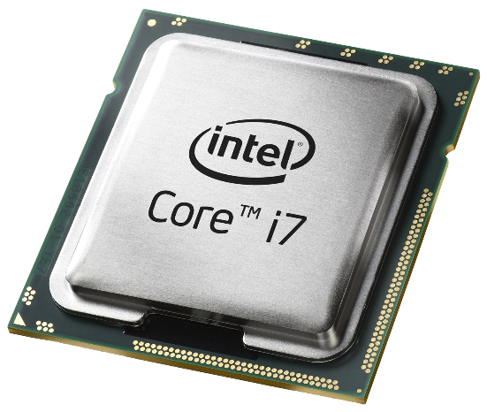

**3.Random Access Memory**

[Random-access memory](https://en.wikipedia.org/wiki/Random-access_memory) (RAM), which stores the code and data that are being actively accessed by the CPU. For example, when a web browser is opened on the computer it takes up memory; this is stored in the RAM until the web browser is closed. It is typically a type of [dynamic RAM](https://en.wikipedia.org/wiki/Dynamic_RAM) (DRAM), such as [synchronous DRAM](https://en.wikipedia.org/wiki/Synchronous_DRAM) (SDRAM), where [MOS memory](https://en.wikipedia.org/wiki/MOS_memory) chips store data on [memory cells](https://en.wikipedia.org/wiki/Memory_cell_(computing)) consisting of MOSFETs and [MOS capacitors](https://en.wikipedia.org/wiki/MOS_capacitor). RAM usually comes on [dual in-line memory modules](https://en.wikipedia.org/wiki/Dual_in-line_memory_module) (DIMMs) in the sizes of 2GB, 4GB, and 8GB, but can be much larger.

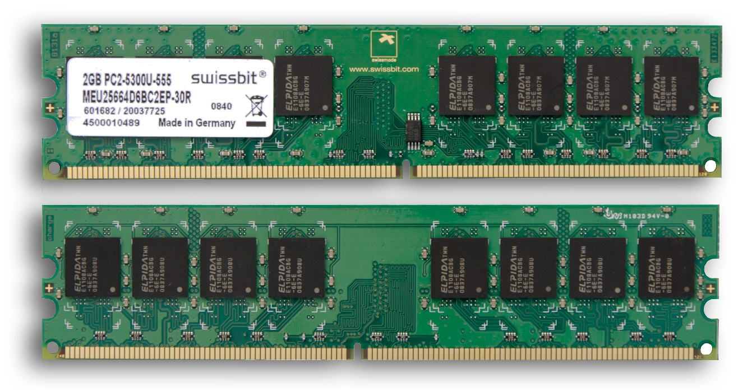

**4.Read Only Memory**

[Read-only memory](https://en.wikipedia.org/wiki/Read-only_memory) (ROM), which stores the [BIOS](https://en.wikipedia.org/wiki/BIOS) that runs when the computer is powered on or otherwise begins execution, a process known as [Bootstrapping](https://en.wikipedia.org/wiki/Bootstrapping_(computing)), or "[booting](https://en.wikipedia.org/wiki/Booting)" or "booting up". The ROM is typically a [nonvolatile BIOS memory](https://en.wikipedia.org/wiki/Nonvolatile_BIOS_memory" \o "Nonvolatile BIOS memory) chip, which stores data on [floating-gate MOSFET](https://en.wikipedia.org/wiki/Floating-gate_MOSFET) memory cells.

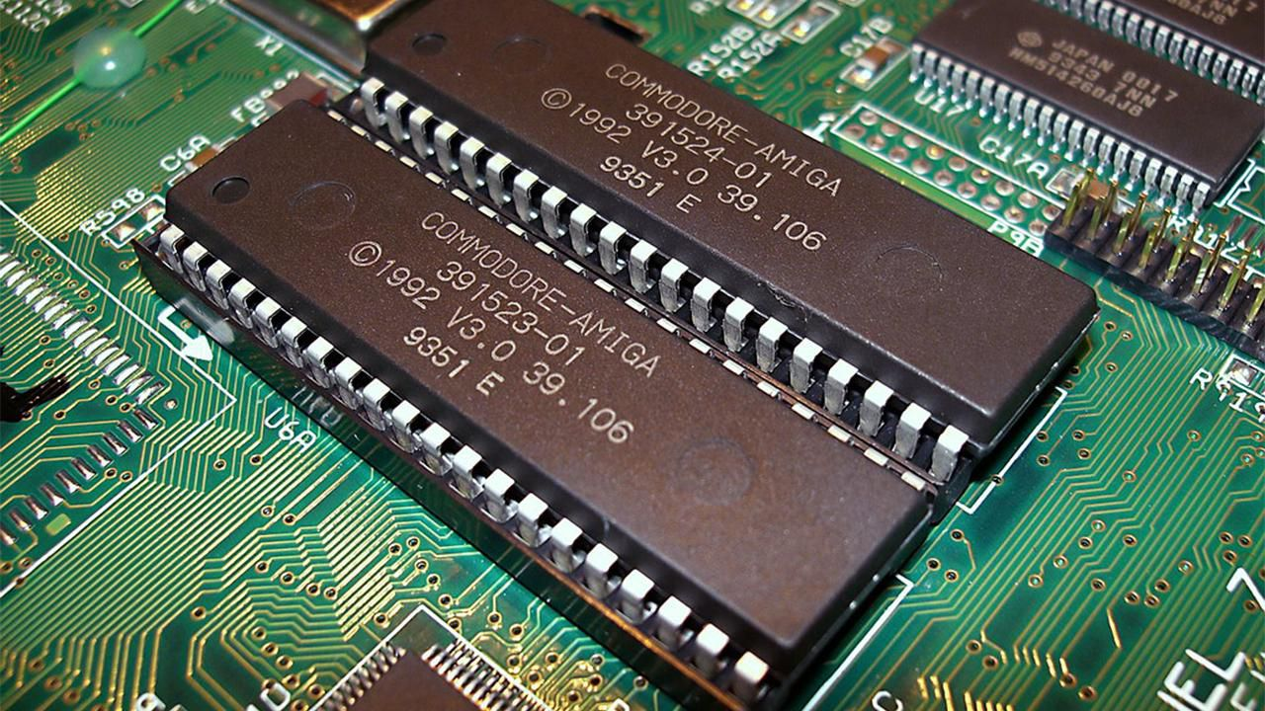

**5.Hard Disk Drive**

A computer hard disk drive (HDD) is a non-volatile data storage device. Non-volatile refers to storage devices that maintain stored data when turned off. All computers need a storage device, and HDDs are just one example of a type of storage device.

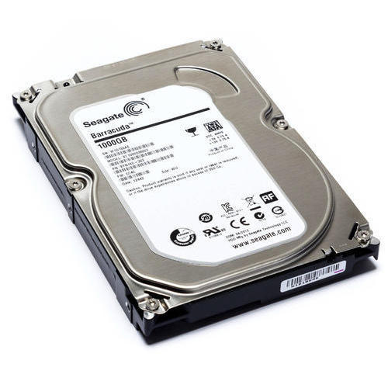

**6.Network Interface card**

A network interface card (NIC) is a hardware component without which a computer cannot be connected over a network. It is a circuit board installed in a computer that provides a dedicated network connection to the computer. It is also called network interface controller, network adapter or LAN adapter

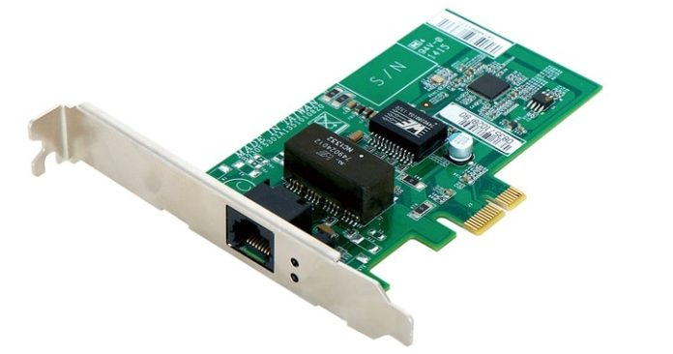

**7.keyborad**

The keyboard is the piece of [computer hardware](https://www.lifewire.com/computer-hardware-2625895) used to input text, characters, and other commands into a computer or similar device.Even though the keyboard is an external [peripheral device](https://www.lifewire.com/peripheral-device-2625951) in a desktop system (it sits outside the main [computer housing](https://www.lifewire.com/what-is-a-computer-case-2618149)), or is "virtual" in a tablet PC, it is an essential part of the complete computer system.Microsoft and Logitech are some of the most popular physical keyboard manufacturers, but many other hardware makers also produce them.

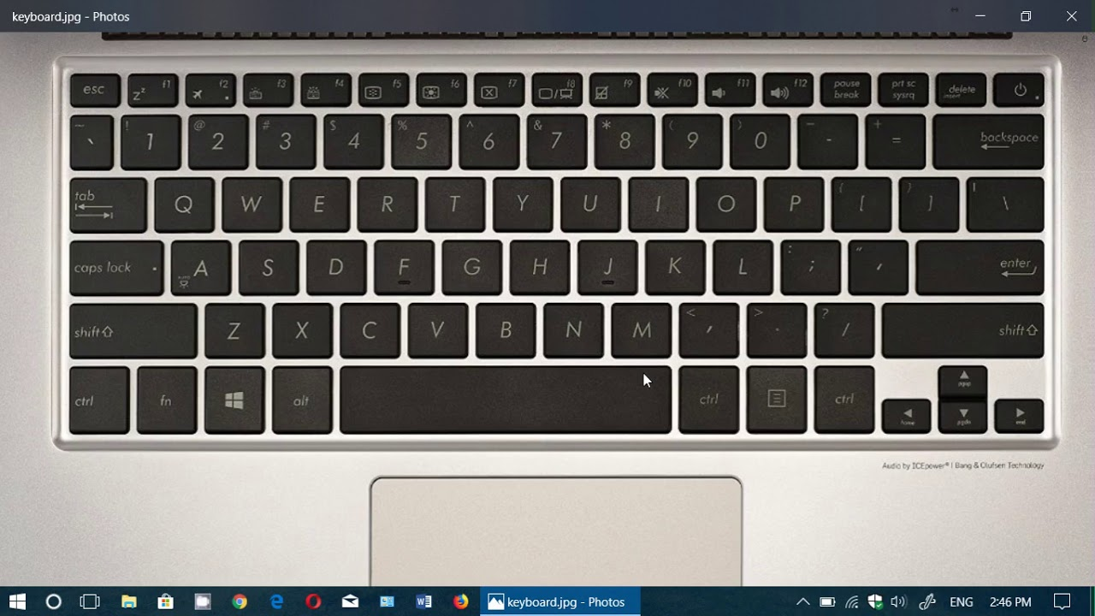

**8.Monitor**

A monitor is a piece of [computer hardware](https://www.lifewire.com/computer-hardware-2625895) that displays the video and graphics information generated by a connected computer through the computer's [video card](https://www.lifewire.com/what-is-a-video-card-2618161).Monitors are similar to TVs but usually display information at a much higher [resolution](https://www.lifewire.com/what-is-resolution-2767449). A monitor is sometimes referred to as a screen, display, video display, video display terminal, video display unit, or video screen.

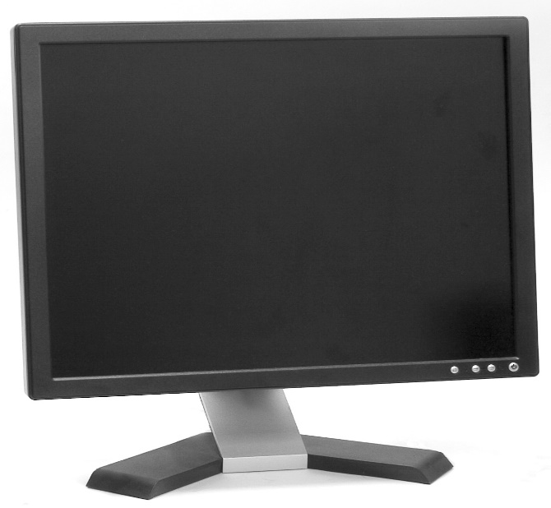

**9.Power Supply Unit**

A power supply unit (PSU) converts [mains AC](https://en.wikipedia.org/wiki/Mains_electricity) to low-voltage regulated [DC power](https://en.wikipedia.org/wiki/DC_power) for the internal components of a computer. Modern personal computers universally use [switched-mode power supplies](https://en.wikipedia.org/wiki/Switched-mode_power_supply). Some [power supplies](https://en.wikipedia.org/wiki/Power_supply) have a manual switch for selecting input voltage, while others automatically adapt to the mains voltage.

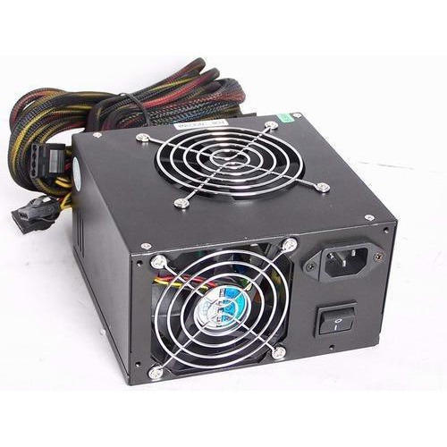

**10.Video Card**

A graphics card (also called a video card, display card, graphics adapter,vga card/vga, video adapter, or display adapter) is an [expansion card](https://en.wikipedia.org/wiki/Expansion_card) which generates a feed of output images to a [display device](https://en.wikipedia.org/wiki/Display_device) (such as a [computer monitor](https://en.wikipedia.org/wiki/Computer_monitor)). Frequently, these are advertised as discrete or dedicated graphics cards, emphasizing the distinction between these and [integrated graphics](https://en.wikipedia.org/wiki/Graphics_processing_unit#Integrated_graphics). At the core of both is the [graphics processing unit](https://en.wikipedia.org/wiki/Graphics_processing_unit) (GPU), which is the main component that performs computations, but should not be confused with the graphics card as a whole, although "GPU" is often used as a [metonymic](https://en.wikipedia.org/wiki/Metonymy) shorthand to refer to graphics cards.

